Media Relations Office
Communications
The Open University
Milton Keynes
United Kingdom
MK7 6AA
t +44 (0)1908 654316
m +44 (0)7901 515891
e Press-office@open.ac.uk
w https://ounews.co/

MEDIA RELEASE

Tuesday, 30 April 2019

Eye witness accuracy affected by background colour in ID parades, research finds
- ID Parades are a common and powerful way to identify criminals
- But background colour variations can impact on accuracy of eye witnesses
- Variations in background colour in ID parades can lead to false identification of innocent suspects
- People are more accurate at identifying same-race faces
New research has found that slight variations in the background colours of green screens used for police identity parades can affect the accuracy of eye witness identifications and increase the likelihood of false IDs of innocent suspects.
Dr Catriona Havard, Senior Lecturer in Psychology at The Open University, led the research which examined the two systems that Police Forces in the UK use for virtual identity parades.
Dr Havard said: “ID parades are one of the most common ways to identify criminals, with police conducting over 100,000 each year in the UK alone, and they can be powerful evidence in securing convictions. However, eyewitness evidence is notoriously error prone. Eliminating any elements which might affect accuracy is one way the Police can help reduce false identifications.”
Researchers ran tests to examine the accuracy of eye witness identifications for own-race and other-race faces and found that people were more accurate in identifying people of the same race as them. The research also concluded that witnesses are more likely to incorrectly identify an innocent face from a line-up when background screen colours are varied.
Eyewitness identification is not used only in the UK, but in a number of countries in Europe and the USA. The Innocence Project, which aims to overturn and prevent wrongful convictions, states, “Mistaken eyewitness identifications contributed to approximately 70% of the more than 350 wrongful convictions in the United States overturned by post-conviction DNA evidence.” The Innocence project also suggests that a suspect should not stand out from the other members of a lineup in any way, and that photographs should be selected that do not bring unreasonable attention to the suspect.
Lineup background variations are problematic
Although lineups use a standard background, often a screen or a white wall, variations in lighting and cameras can result in slight differences in the hues of background for line-up members. Having differences in the background of the lineups can mean that some individuals may stand out more than other individuals.
Findings show different background hues affect identification accuracy
The research team created a set of ten images, five of which had very slightly different green background hues. They showed volunteers a face for five seconds then presented the ten faces and asked them to identify the original face shown. Only half of the tests included the original face to test whether the eye witness volunteers would falsely identify someone.
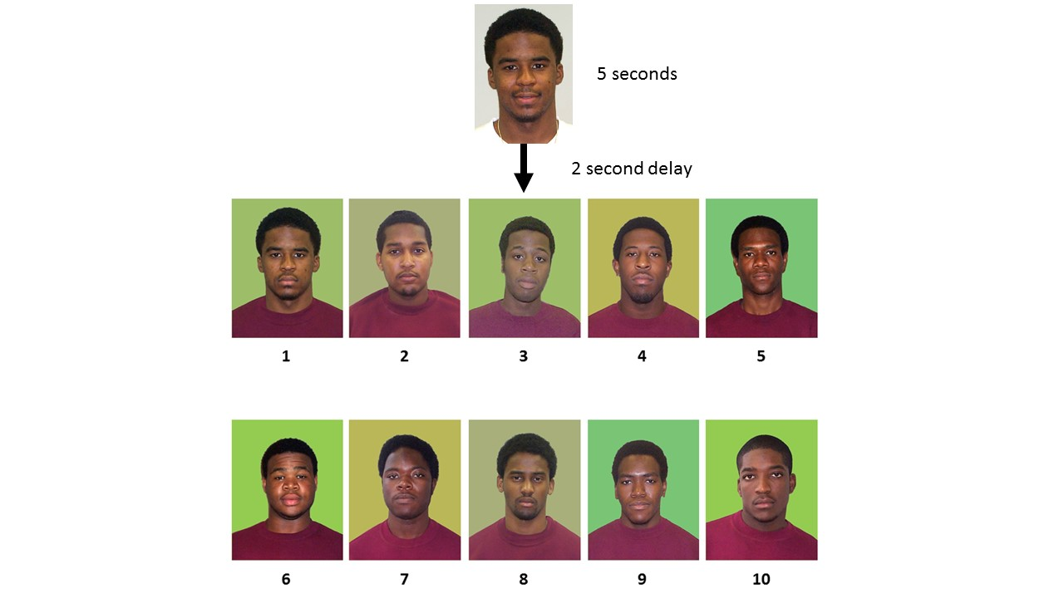
The findings were:
- Eye witnesses are better at identifying people the same race as them
- Half of mistaken identifications were white people incorrectly identifying black people
- When it came to correctly identifying the original face, the varied backgrounds did not make a difference
- There were more false identifications with the altered coloured backgrounds
- When people were shown a line-up which didn’t include the perpetrator, regardless of the colour they were likely to pick someone innocent over a third of the time.
Real world implications for police identity parades
Dr Havard concludes: “The findings of this study have real world implications for reducing cases of mistaken identification that could lead to wrongful convictions. Although there are some factors, such as own-race bias, that can’t be controlled by the police, other factors such as having uniform line-up backgrounds can be controlled. This will ensure that any line-up member doesn’t stand out, and reduce false identifications.”
The research team was Dr Catriona Havard, The Open University, Dr Martin Thirkettle, Sheffield Hallam University, and Dr Stephanie Richter, The Open University.
The research paper The effects of changes in background colour on the identification of own and other-race faces is published in i-Perception journal https://journals.sagepub.com/doi/10.1177/2041669519843539.

Notes to Editors
About The Open University
The Open University (OU) is the largest academic institution in the UK and a world leader in flexible distance learning. Celebrating its 50th anniversary in 2019, the university was founded with a clear purpose: to open up education to all. Since those beginnings in 1969, the OU has taught more than 2 million students worldwide and has over 170,000 current students, including more than 15,000 overseas.

Over 75% of students are in full-time or part-time employment, and three out of five FTSE 100 companies have sponsored staff to take OU courses.

In the latest assessment exercise for university research (Research Excellence Framework, 2014), nearly three quarters (72%) of OU research was assessed as 4 or 3 star – the highest ratings available, awarded to research that is world-leading or internationally excellent. The OU is unique among UK universities having both an access mission and demonstrating research excellence.

The OU has had a unique educational partnership with the BBC since 1971, collaborating on a range of content across TV, radio and digital channels/platforms. Each year the OU co-produces approximately 35 prime-time TV and radio series such as, Blue Planet II, The Prosecutors and Inside the Foreign Office. We achieved more than 351m viewing and listening events last year which prompted more than 1.6 million visits to our 17/18 broadcast related content on the OU’s free learning website, OpenLearn

Regarded as the UK’s major e-learning institution, the OU is a world leader in developing technology to increase access to education on a global scale. Its vast ‘open content portfolio’ includes free study units, as well as games, videos and academic articles, which have reached over 36 million people.

For further information please visit The Open University

